

Analytics in a Day  
Azure Synapse + Power BI better together

Exercise 06

# Develop a Power BI Model

## Overview

The estimated time to complete this exercise is 45 minutes.

Important: You must use the lab Azure credentials to connect to Azure Synapse and to publish content to Power BI.

In this exercise, you are working in the role of a data architect or BI developer.

You will use Power BI Desktop to develop a data model over your Azure Synapse Wide World Importers (WWI) data warehouse. The data model will allow you to publish a semantic layer of ther data warehouse. Comprising six tables, it will define relationships, hierarchies, calculations, and friendly and consistent names. The data model will become an intuitive and high performance source for Power BI reports.

## Section 1: Create the Model

In this section, you will create a DirectQuery model to support Power BI analysis and reporting of the data warehouse sale subject.

### Task 1: Prepare Your Environment

In this task, you will prepare your environment.

1. Open Power BI Desktop.
2. At the top-right corner, verify that you are signed in using the lab Azure credentials.
3. If you are not signed in using the lab Azure credentials, you must now sign in with those credentials.
4. On the File tab (backstage view), select Option and Settings, and then select Options.

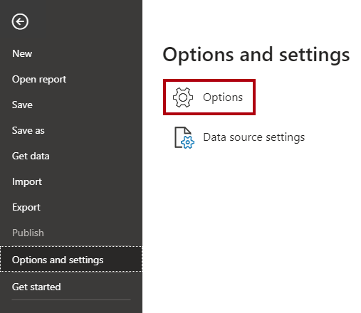

1. In the Options window, at the left, select the Preview Features page.

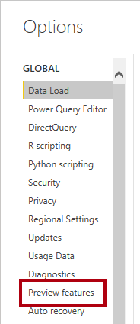

1. Check the Store Datasets Using Enhanced Metadata Format checkbox.



This preview feature is required to complete your model design.

1. Click OK.

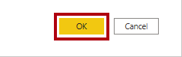

1. When notified that the feature requires a restart, click OK.
2. Close Power BI Desktop.
3. Open a new web browser session, and then navigate to <https://powerbi.com>.
4. If you are not signed in automatically, click Sign In, and then sign in using the lab Azure credentials.
5. At the top-right corner, ensure the new look is On.



### Task 2: Download a Dataset File

In this task, you will download a Power BI data source file from Synapse Studio.

1. In the Azure Synapse web browser session (opened in your previous exercise), navigate to Synapse Studio.
2. At the left, select the Develop hub.

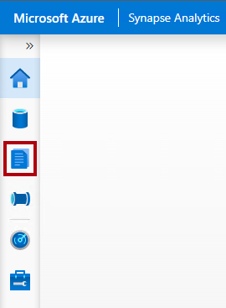

1. In the Develop pane, expand the Power BI workspace, and then select Power BI datasets.

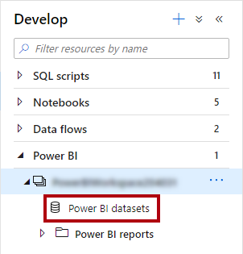

1. In the Power BI Datasets pane, click New Power BI Dataset.

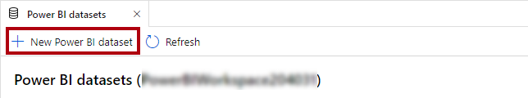

1. Hover the cursor over your SQL pool, and then use the link to download the .pbids file.

A .pbids file contains a connection to your SQL pool. It’s a convenient way to start your project. When opened, it’ll create a new Power BI Desktop solution that already stores the connection details to your SQL pool.

1. When the .pbids file has downloaded, open it.

When the file opens, it’ll prompt you to create queries using the connection. You’ll define those queries in the next task.

### Task 3: Create Model Queries

In this task, you will create six Power Query queries that will each load as a table to your model.

Power Query is a Microsoft technology used to connect to data stores, profile data, and transform data. You’ll define a query for each table your model.

1. In Power BI Desktop, in the Navigator window, select (don’t check) the wwi.DimCity table.
2. In the right pane, notice the preview result, which shows a subset of the table rows.
3. To create queries (which will become model tables), check the following six tables:

* wwi.DimCity
* wwi.DimCustomer
* wwi.DimDate
* wwi.DimEmployee
* wwi.DimStockItem
* wwi.FactSale

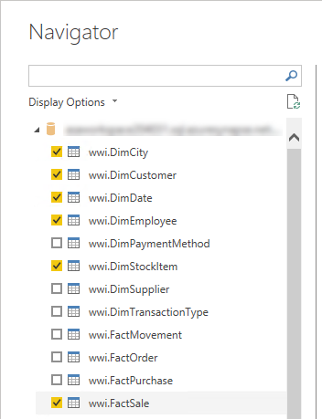

1. To apply transformations to the queries, at the bottom-right, click Transform Data.



Transforming the data allows you to define what data will be available in your model.

1. In the Connection Settings window, select the DirectQuery option.

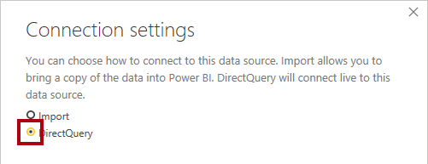

This decision is important. DirectQuery is a storage mode. A model table that uses DirectQuery storage mode doesn’t store data. So, when a Power BI report visual queries a DirectQuery table, Power BI sends a native query to the data source. This storage mode is often used for large data stores like Azure Synapse Analytics (because it’s impractical or uneconomic to import large data volumes) or when near real-time results are required.

1. Click OK.

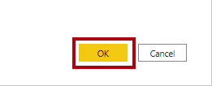

1. In the Power Query Editor window, in the Queries pane (located at the left), notice there is one query for each table you requested.

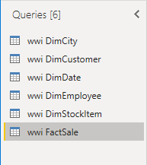

You’ll now revise the definition of each query. Each query will become a model table when they are applied to the model. So, you’ll now rename them so they’re described in more friendly and concise ways, and apply transformations to deliver the columns required by reports.

1. Select the wwi DimCity query.

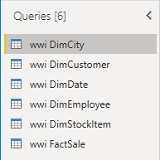

1. In the Query Settings pane (located at the right), to rename the query, in the Name box, replace the text with Geography, and then press Enter.

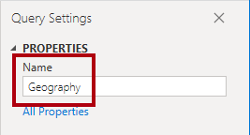

1. On the Home ribbon tab, from inside the Manage Columns group, click the Choose Columns icon.

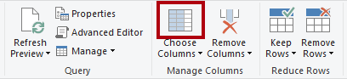

1. In the Choose Columns window, to uncheck all checkboxes, uncheck the first checkbox.

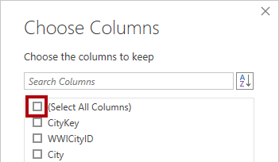

1. Check the following seven columns.

* CityKey
* City
* StateProvince
* Country
* SalesTerritory
* Region
* Subregion

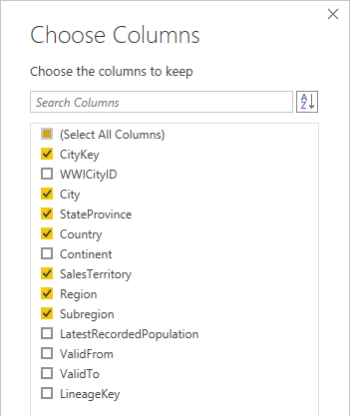

This selection of columns determine what will be available in your model.

1. Click OK.

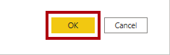

1. In the Query Settings pane, in the Applied Steps list, notice that a step was added to remove other columns.

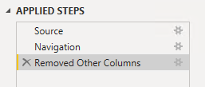

Power Query defines steps to achieve the desired structure and data. Each transformation is a step in the query logic.

1. To rename the StateProvince column, double-click the StateProvince column header.
2. Insert a hyphen character (-) between the word State and the word Province, and then press Enter.

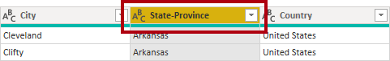

1. Notice that a new applied step is added to the query.

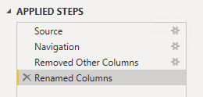

1. Rename the SalesTerritory column as Sales Territory (insert a space between the two words).
2. To validate the query design, in the status bar (located along the bottom of the window), verify that the query has seven columns.



Important: If the query design does not match, review the exercise steps to make any corrections.

The design of the Geography query is now complete.

1. In the Applied Steps pane, right-click the last step, and then select View Native Query.

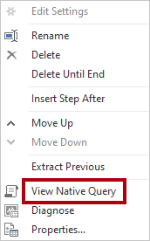

1. In the Native Query window, review the SELECT statement that reflects the query design.

This concept is important. A native query is what Power BI uses to query the data source. To ensure best performance, the database developer should ensure this query is optimized by creating appropriate indexes, etc.

1. To close the Native Query window, click OK.

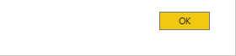

1. Select the wwi DimCustomer query.

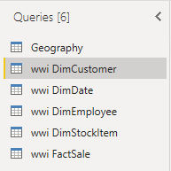

1. Rename the query as Customer.
2. Remove all columns, except:

* CustomerKey
* Customer
* Category
* BuyingGroup

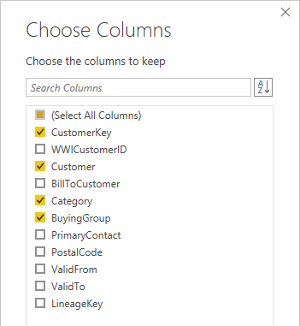

1. Rename the BuyingGroup column as Buying Group (insert a space between the two words).
2. Verify that the query has four columns.

The design of the Customer query is now complete.

1. Select the wwi DimDate query.

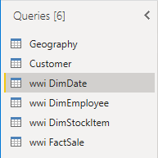

1. Rename the query as Date.
2. Remove all columns, except:

* Date
* CalendarMonthNumber
* CalendarMonthLabel
* CalendarYear
* CalendarYearLabel

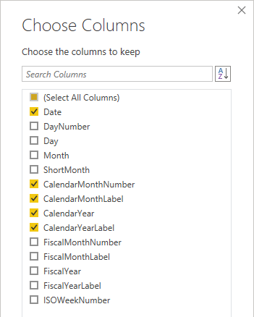

1. Rename the following columns:

* CalendarMonthLabel as Month
* CalendarYearLabel as Year

1. To add a computed column, on the Add Column ribbon tab, from inside the General group, click Custom Column.

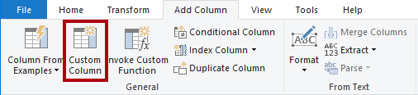

1. In the Custom Column window, in the New Column Name box, replace the text with MonthKey.

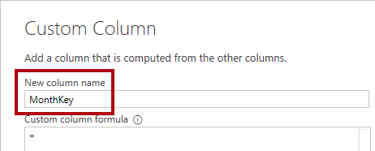

1. In the Custom Column Formula box, enter the following formula:
   1. Power Query (M)
   2. ([CalendarYear] * 100) + [CalendarMonthNumber]

Tip: To add the column references to the formula, in the Available Columns list, simply double-click a column.

The formula produces a unique key value for each month of a calendar year. It’s required to ensure that the calendar month labels sort in chronologic order. You’ll use this column in the next exercise when you configure the Month column sort order.

1. Click OK.

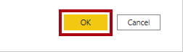

1. Remove the CalendarMonthNumber and CalendarYear columns.

Tip: You can remove the columns using on of three techniques. First, you can open the Choose Columns window, and then uncheck those columns. Second, you can multi-select the columns and use the ribbon Remove Columns commands. Or, third, you can multi-select the columns, right-click the selection, and then select the context menu to Remove Columns options.

1. Review the native query, and notice the SQL expression used to compute the MonthKey column.

This design isn’t optimal because this calculation will need to be computed every time the Date table is queried. In a real world solution, query performance would be better if the MonthKey column values are stored in the wwi.DimDate table (or a materialized view).

1. Verify that the query has four columns.

The design of the Date query is now complete.

1. Select the wwi DimEmployee query.

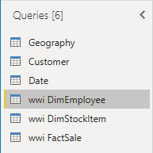

1. Rename the query as Salesperson.
2. To filter the table rows to only employees who are salespeople, in the IsSalesperson column header, click the down arrow, and then uncheck the FALSE item.

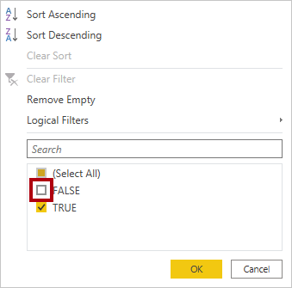

1. Click OK.
2. Remove all columns, except:

* EmployeeKey
* Employee

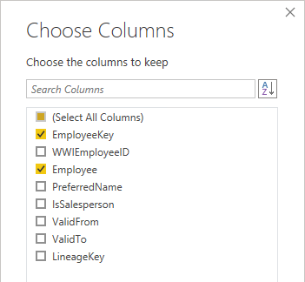

1. Rename the Employee column as Salesperson.
2. Review the native query, and notice the WHERE clause that filters the table.
3. Verify that the query has two columns.

The design of the Salesperson query is now complete.

1. Select the wwi DimStockItem query.

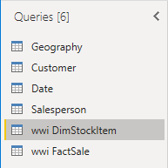

1. Rename the query as Product.
2. Remove all columns, except:

* StockItemKey
* Stock Item
* Color

1. Rename the Stock Item column as Product.
2. Verify that the query has three columns.

The design of the Product query is now complete.

1. Select the wwi FactSale query.

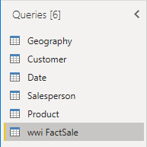

1. Rename the query as Sale.
2. Remove all columns, except:

* CityKey
* CustomerKey
* StockItemKey
* InvoiceDateKey
* SalespersonKey
* Quantity
* UnitPrice
* Profit

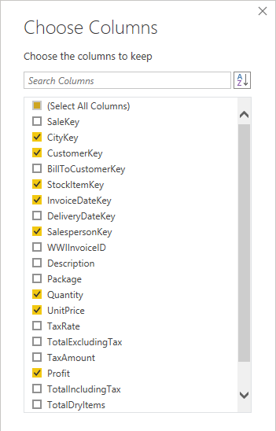

1. Rename the following columns:

* UnitPrice as Unit Price
* Profit as Profit Amount

1. Add a computed column using the following formula to create the Sale Amount column.
   1. Power Query (M)
   2. [Quantity] * [Unit Price]
2. To modify the Sale Amount column data type, in the column header, click the ABC123 icon, and then select Decimal Number.

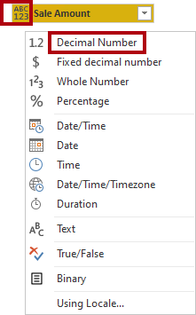

1. Verify that the query has nine columns.

The design of the Sale query is now complete.

1. To apply the queries, on the Home ribbon tab, from inside the Close group, click the Close & Apply icon.

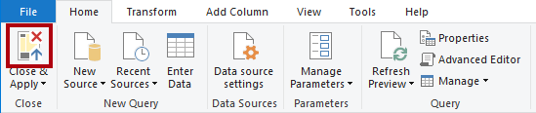

Each query is applied to create a model table. Because the data connection is using DirectQuery storage mode, only the model structure is created. No data is imported. The model now consists of one table for each query.

1. In Power BI Desktop, at the left, switch to Model view.

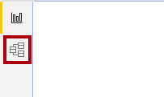

Model view allows you to see all tables in the model diagram. It also allows you to configure many model properties. You’ll configure model properties in the next exercise.

1. In the model diagram, notice that there are six tables (some may be out of view—scroll horizontally to see them all).
2. To save the Power BI Desktop solution, on the File tab (backstage view), select Save.
3. Save the file as Sale Analysis to an easy-to-remember location in your file system.
4. Open File Explorer, and navigate to the file system location.
5. Notice the file size that is very small (~25 KB).

The Power Query queries have been loaded to create model tables. In the next exercise, you’ll complete the design of the model by creating relationships and applying model configurations.

## Section 2: Develop the Model

In this section, you will develop the model by creating relationships, setting table and column properties, and creating measures.

### Task 1: Create Relationships

In this task, you will create relationships between all model tables. Each relationship with relate the Sale fact table to a dimension table.

1. In Power BI Desktop, in the model diagram, organize the tables as follows:

* Position the Sale table at the center of the diagram, and then surround it with the five dimension tables
* Ensure that the Date and Geography tables are next to each other

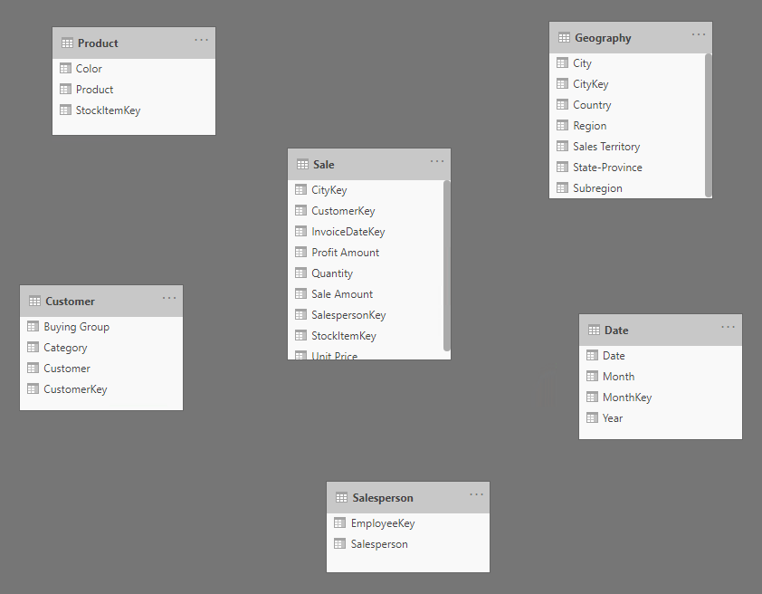

1. To create the first relationship, from the Sale table, drag the CityKey column, and then drop it on the Geography table CityKey column.

Sometimes this technique doesn’t work properly. In this case, deselect the column you want to drag by selecting a different column, and then start the drag operation again.

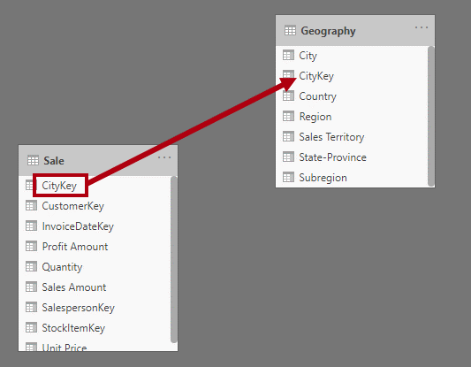

1. In the Create Relationship window, at the bottom-left, check the Assume Referential Integrity checkbox.

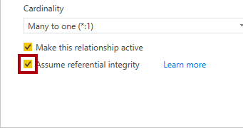

When referential integrity is assumed, Power BI will join tables by using a more efficient INNER join (instead of an OUTER join). However, it’s important that there are matching values on both sides of the join, because an INNER join will eliminate rows from the query result when values don’t match. At design time, sometimes Power BI Desktop will attempt to validate that data integrity is in place. If the validation takes too long, when prompted, you can skip validation process.

1. Click OK.

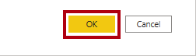

1. In the diagram, notice the relationship is a connector between tables.

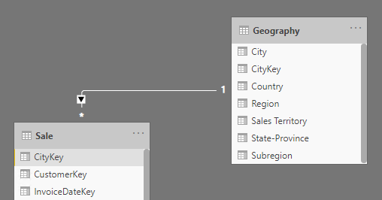

Model relationships propagate filters between tables. So, for example, if a report filters the State-Province column by California, a filter propagates to the Sale table to ensure rows for that state are queried.

1. Notice there is a one-side (1) and many-side (*) to the relationship.

Dimension tables, like Geography, are always the one-side of the relationship. These tables include a unique column (dimension key column). Filters always propagate from the one-side to the many-side. In more advanced scenarios, filters can propagate in both directions. In this exercise, you won’t configure bi-directional relationships. For more information about relationships, see [Model relationships in Power BI Desktop](https://docs.microsoft.com/power-bi/transform-model/desktop-relationships-understand).

1. Create four additional relationships and configure each to assume referential integrity:

* Relate the Sale table CustomerKey column to the Customer table CustomerKey column
* Relate the Sale table InvoiceDateKey column to the Date table Date column
* Relate the Sale table SalespersonKey column to the Salesperson table EmployeeKey column
* Relate the Sale table StockItemKey column to the Product table StockItemKey column

1. Verify that all tables are now related.

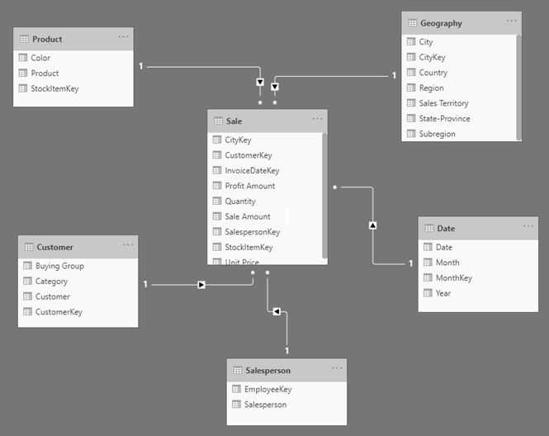

1. Verify that the one-side of each relationship is on the dimension table side.

If a relationship is configured to filter in the wrong direction, double-click the relationship, and then modify the Cardinality property.

1. Save the Power BI Desktop solution.

### Task 2: Configure the Geography Table

In this task, you will add two hierarchies to the Geography table and configure data categorization for three columns.

1. In the model diagram, in the Geography table, right-click the Region column, and then select Create Hierarchy.

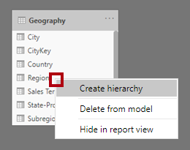

Hierarchies provide ease of navigation across the model data, allowing drill down and drill up operations. Always create a hierarchy using the column that’s to become the first (top) level of the hierarchy.

1. In the Properties pane (located at the right of the model diagram), in the Name box, replace the text with Sales Organization.

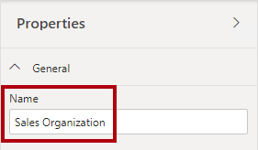

1. In the Properties pane, in the Hierarchy dropdown list (select a column to add a level), select the Subregion column.
2. Notice that the column was added as the next level in the hierarchy.

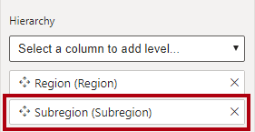

1. Add the following three additional columns to the hierarchy, in this order:

* Sales Territory
* State-Province
* City

1. To complete the hierarchy configuration, click Apply Level Changes.

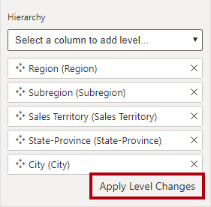

1. Create a second hierarchy in the Geography table named Geography, with the following levels:

* Country
* State-Province
* City

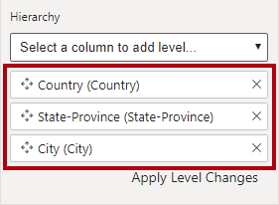

1. In the Geography table, select the Country column.
2. In the Properties pane, expand the Advanced section, and then in the Data Category dropdown, select Country/Region.

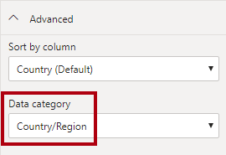

Data categorization defines additional metadata. In this case, the column is categorized as a spatial column, and as such Power BI will—by default—visualize it by using map visuals.

1. Set the following additional column data categorizations:

* Categorize the State-Province column as State or Province
* Categorize the City column as City

Configuration of the Geography table is now complete.

### Task 3: Configure the Date Table

In this task, you will add a hierarchy to the Date table and configure the Month column sort order.

1. In the Date table, create a hierarchy named Calendar, with the following levels:

* Year
* Month

1. In the Date table, select the Month column.
2. In the Properties pane, in the Advanced section, in the Sort by Column dropdown list, select MonthKey.

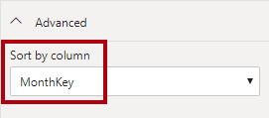

The alphabetic Month column values will now sort by the chronologic MonthKey column values.

Configuration of the Date table is now complete.

### Task 4: Configure the Sale Table

In this task, you will configure the Sale table columns.

1. In the Sale table, select the Quantity column.
2. In the Properties pane, in the Formatting section, set the Thousands Separator property to Yes.

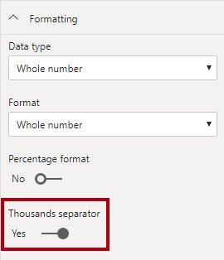

Formatting columns ensures appropriate and consistent formatted values in report visuals.

1. To multi-select columns, first press the Ctrl key, and then select the following three columns:

* Profit Amount
* Sale Amount
* Unit Price

1. In the Properties pane, in the Formatting section, in the Format dropdown list, select Currency.

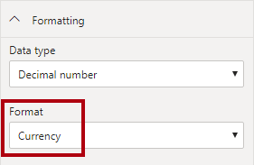

1. Select the Unit Price column (you might need to first de-select the multi-selection of columns, and then select this single column).
2. In the Properties pane, in the Advanced section, in the Summarize by dropdown list, select Average.

By default, numeric column will be aggregated by using the sum function. In this case, it doesn’t make sense to sum unit price values together. The default summarization for this column now averages unit prices.

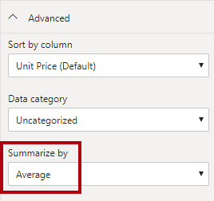

Configuration of the Sale table is now complete.

### Task 5: Hide Columns

In this task, you will hide columns that are not appropriate for reporting.

Typically, you hide key columns that are used to relate tables or sort columns.

1. Multi-select the following 10 columns:

* Geography table CityKey column
* Date table MonthKey column
* Customer table CustomerKey column
* Salesperson table EmployeeKey column
* Product table StockItemKey column
* Sale table CityKey, CustomerKey, InvoiceDateKey, SalespersonKey, and StockItemKey columns

1. In the Properties pane, set the Is Hidden property to Yes.

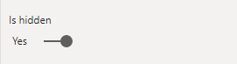

### Task 6: Mark the Date Table

In this task, you will mark the Date table.

Marking a date table is required to ensure the Data Analysis Expressions (DAX) time intelligence functions work correctly. You’ll create a measure and define a time intelligence calculation in the next task.

1. Switch to Report view.

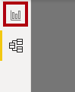

Marking a date table cannot be done in Model view.

1. In the Fields pane (located at the right), select the Date table.
2. On the Table Tools contextual ribbon tab, from inside the Calendars group, click Mark as Date Table, and then select Mark as Date Table.

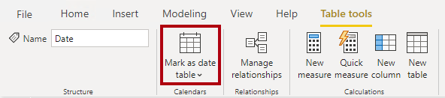

1. In the Mark as Date Table window, in the Date Column dropdown list, select Date.

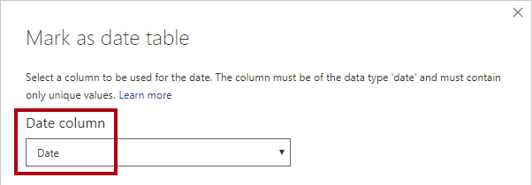

1. When validation has succeeded, click OK.

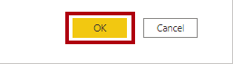

Validation ensures the column contains unique dates, no missing dates, and no gaps between dates. These conditions are a prerequisite to ensure the DAX time intelligence filters work correctly.

### Task 7: Create Measures

In this task, you will create two measures. Measures are expressions that summarize model data.

1. In the Fields pane, right-click the Sale table, and then select New Measure.

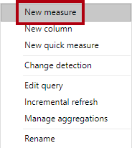

1. In the formula bar (located directly beneath the ribbon), replace the text with the following measure definition, and then press Enter.

Tip: When entering the formula, to enter a carriage return, press Shift+Enter.

* 1. DAX
  2. Profit YTD =  
     TOTALYTD(  
      SUM(Sale[Profit Amount]),  
      'Date'[Date]  
     )

This formula uses a built-in DAX time intelligence function to accumulate the sum of the Sale table Profit Amount column values within the year to produce a year-to-date (YTD) result.

1. In the Fields pane, notice the addition of the measure.

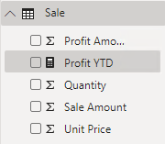

Measures are identified by the calculator icon.

1. To configure formatting, in the Fields pane, ensure the measure is selected (not checked).
2. On the Measure Tools contextual ribbon, from inside the Formatting group, in the dropdown list, select Currency, and set the decimal places to 2.

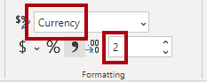

1. Add a second measure to the Sale table using the following formula:
   1. DAX
   2. Profit % All Geography =  
      DIVIDE(  
       SUM(Sale[Profit Amount]),  
       CALCULATE(  
       SUM(Sale[Profit Amount]),  
       REMOVEFILTERS(Geography)  
       )  
      )

This formula divides the sum of the Sale table Profit Amount column by the same expression, but by using a different filter context. The denominator removes any filters applied to the Geography table.

1. Format the Profit % All Geography measure as a percentage.

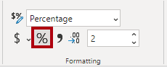

1. Save the Power BI Desktop solution.

All model configurations have now been made. In the next exercise, you’ll create a test report and measure query performance.

## Section 3: Test the Model

In this section, you will create a test report. You will then use Performance Analyzer to measure query performance.

### Task 1: Create a Test Report

In this task, you will design a simple report to test query performance.

1. In Power BI Desktop, in Report view, to add a slicer to the report canvas, in the Visualizations pane, click the slicer icon.

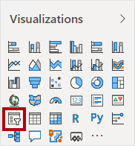

1. In the Fields pane, from the Date table, drag the Year field (not the year level of the Calendar hierarchy) to the slicer.
2. Filter the slicer by CY2012.

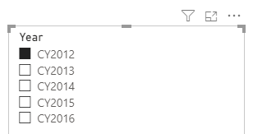

1. To create a new visual, first select an empty area of the report canvas.

Selecting the report canvas de-selects the slicer visual.

1. To add a table visual to the report canvas, in the Visualizations pane, click the table visual icon.

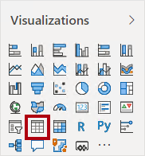

1. Position the table visual to the right of the slicer, and then resize it as large as possible.
2. Drag and drop the following visuals into the table visual:

* Date table Month field (not the Month hierarchy level)
* Sale table Profit Amount field
* Sale table Profit YTD field

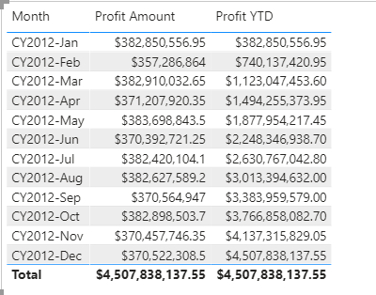

Performance is likely to be slow, as the model hasn’t yet been optimized. You’ll be optimizing the model with aggregations in Exercise 07.

1. In the Visualizations pane, in the Values well, to remove the fields, click X next to each field.

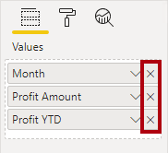

1. Drag and drop the following fields into the table visual:

* Geography table State-Province field (it is second from the bottom—do not use the State-Province hierarchy level)
* Sale table Profit Amount field
* Sale table Profit % Total Geography field

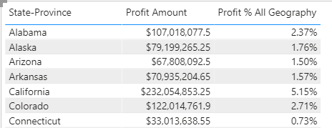

### Task 2: Measure Query Performance

In this task, you will use Performance Analyzer to measure query performance.

1. On the View ribbon tab, from inside Show Panes group, select Performance Analyzer.

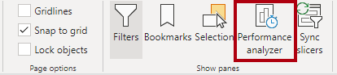

1. In the Performance Analyzer pane, click Start Recording.

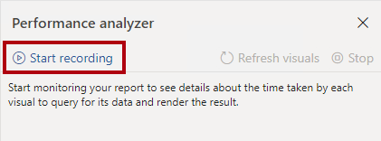

When recording, Performance Analyzer captures statistics when visual query data.

1. In the Performance Analyzer pane, click Refresh Visuals.

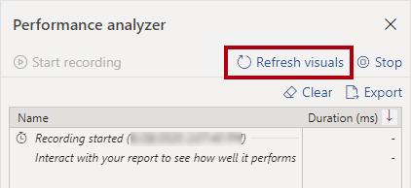

1. In the list, notice the duration statistics, which are recorded in milliseconds.
2. Expand the Table node.
3. Notice that it is possible to determine the duration of the DirectQuery process, and that presently it is several seconds.

Report users demand fast responses. Usually, they’re very happy when visuals refresh in less than one second, but are still happy when it takes no more than about five seconds.

1. To copy the SQL query to the clipboard, click the Copy Query.

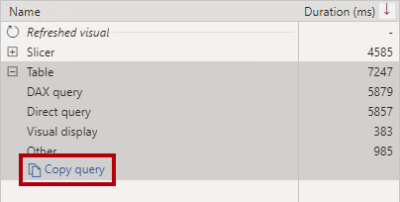

1. Open a text editor, like Notepad, and paste in the query.
2. Review the query.

The query statement provides you with insight into how Power BI queries Azure Synapse Analytics. It can lead to you to apply specific optimizations in the data source, like indexes or materialized views, to improve query performance.

1. Close the text editor, without saving changes.
2. In the Performance Analyzer pane, click Stop.

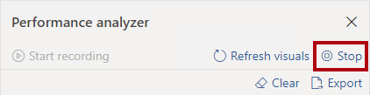

1. Save the Power BI Desktop solution.

The lab is now complete. Leave your Power BI Desktop solution open ready to start the next lab (when instructed to do so).

In Exercise 07, you’ll improve query performance by creating an aggregation table.

## Summary

In this exercise, you used Power BI Desktop to develop a data model over your Azure Synapse Wide World Importers (WWI) data warehouse. It comprises six tables.

## Terms of Use

© 2020 Microsoft. All rights reserved.

By using this hands-on lab, you agree to the following terms:

The technology/functionality described in this hands-on lab is provided by Microsoft Corporation in a “sandbox” testing environment for purposes of obtaining your feedback and to provide you with a learning experience. You may only use the hands-on lab to evaluate such technology features and functionality and provide feedback to Microsoft. You may not use it for any other purpose. Without written permission, you may not modify, copy, distribute, transmit, display, perform, reproduce, publish, license, create derivative works from, transfer, or sell this hands-on lab or any portion thereof.

COPYING OR REPRODUCTION OF THE HANDS-ON LAB (OR ANY PORTION OF IT) TO ANY OTHER SERVER OR LOCATION FOR FURTHER REPRODUCTION OR REDISTRIBUTION WITHOUT WRITTEN PERMISSION IS EXPRESSLY PROHIBITED.

THIS HANDS-ON LAB PROVIDES CERTAIN SOFTWARE TECHNOLOGY/PRODUCT FEATURES AND FUNCTIONALITY, INCLUDING POTENTIAL NEW FEATURES AND CONCEPTS, IN A SIMULATED ENVIRONMENT WITHOUT COMPLEX SET-UP OR INSTALLATION FOR THE PURPOSE DESCRIBED ABOVE. THE TECHNOLOGY/CONCEPTS REPRESENTED IN THIS HANDS-ON LAB MAY NOT REPRESENT FULL FEATURE FUNCTIONALITY AND MAY NOT WORK THE WAY A FINAL VERSION MAY WORK. WE ALSO MAY NOT RELEASE A FINAL VERSION OF SUCH FEATURES OR CONCEPTS. YOUR EXPERIENCE WITH USING SUCH FEATURES AND FUNCITONALITY IN A PHYSICAL ENVIRONMENT MAY ALSO BE DIFFERENT.

FEEDBACK If you give feedback about the technology features, functionality and/or concepts described in this hands-on lab to Microsoft, you give to Microsoft, without charge, the right to use, share and commercialize your feedback in any way and for any purpose. You also give to third parties, without charge, any patent rights needed for their products, technologies and services to use or interface with any specific parts of a Microsoft software or service that includes the feedback. You will not give feedback that is subject to a license that requires Microsoft to license its software or documentation to third parties because we include your feedback in them. These rights survive this agreement.

MICROSOFT CORPORATION HEREBY DISCLAIMS ALL WARRANTIES AND CONDITIONS WITH REGARD TO THE HANDS-ON LAB, INCLUDING ALL WARRANTIES AND CONDITIONS OF MERCHANTABILITY, WHETHER EXPRESS, IMPLIED OR STATUTORY, FITNESS FOR A PARTICULAR PURPOSE, TITLE AND NON-INFRINGEMENT. MICROSOFT DOES NOT MAKE ANY ASSURANCES OR REPRESENTATIONS WITH REGARD TO THE ACCURACY OF THE RESULTS, OUTPUT THAT DERIVES FROM USE OF THE VIRTUAL LAB, OR SUITABILITY OF THE INFORMATION CONTAINED IN THE VIRTUAL LAB FOR ANY PURPOSE.

DISCLAIMER This lab contains only a portion of new features and enhancements in Microsoft Power BI. Some of the features might change in future releases of the product.